Form Drawing 2

Step with a Slide
A step with a slide lays in the yard.
Use the green wool in the home learning pack to form the pattern.
Use a rope you have one at home
Step on the first step (wool), follow the line, walk upstairs and run down the slide.
Do it a few times.
Wind the wool and put it away. 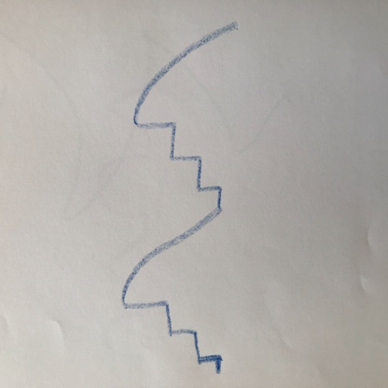
Walk on the ‘invisible line’ of step with a slide.

When you are ready, sit down and draw the step with a slide pattern with:
- Your nose.
- Your right knee.
- Your right toe.
- Your right hand.
- Practice on practice book.
Draw the step with a slide on your yellow Form Drawing book with a stick crayon.

