Form Drawing 1

Leaf Falling
A leafing is falling from the sky.
Use the green wool in the home learning pack to form the pattern on the floor.
Step on the left top of wool (see pic). Follow the line, walk sideways to the right then left, repeat until the leaf falls on the ground.
Do it a few times.
Wind the wool and put it away.
Walk on the ‘invisible line’ of the leaf falling.
back

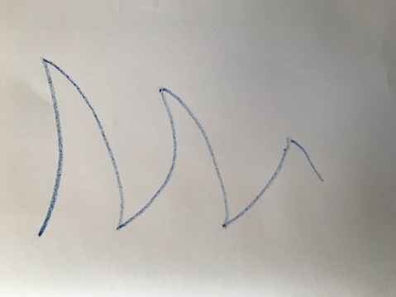
When you are ready, sit down and draw the leaf falling pattern with:
- Your nose.
- Your right knee.
- Your right hand.
Draw the leaf falling on your yellow Form Drawing book with a stick crayon.

